**Dr. Sen’s Dental Clinic**

**Let’s Go**

**Username:**

**Password:**

**Dr. Sen’s Dental Clinic**

**Let’s Go**

**Username:**

**Password:**





**Dr. Sen’s Dental Clinic**

**Let’s Go**

InvalidUsername

**************

**Username:**

**Password:**

Invalid username or password

**Logout**

**Dr. Sen’s Dental Clinic**

**Patient Records**

**New Patient**

**New Patient Flow**

**Full Name:**

**Age:**

**Gender:**

**Male**

**Female**

**Address:**

**Phone No.:**

**Email Id:**

**Occupation:**

**Date of Visit:**

**Chief Complaint (C/C):**

**On Examination (O/E):**

**Medical History:**

**Investigation:**

**Advice:**

**Work Done:**

**Medicine:**

**Next Appointment Date:**

**Logout**

**Dr. Sen’s Dental Clinic**









**Cancel**

**Preview**

**Full Name:**

**Age:**

**Gender:**

**Male**

**Female**

**Address:**

**Phone No.:**

**Email Id:**

**Occupation:**

**Date of Visit:**

**Chief Complaint (C/C):**

**On Examination (O/E):**

**Medical History:**

**Investigation:**

**Advice:**

**Work Done:**

**Medicine:**

**Next Appointment Date:**

**Logout**

**Dr. Sen’s Dental Clinic**

**Preview**

**Cancel**









**Full Name:**

**Age:**

**Gender:**

**Male**

**Female**

**Address:**

**Phone No.:**

**Email Id:**

**Occupation:**

**Date of Visit:**

**Chief Complaint (C/C):**

**On Examination (O/E):**

**Medical History:**

**Investigation:**

**Advice:**

**Work Done:**

**Medicine:**

**Next Appointment Date:**

**Logout**

**Dr. Sen’s Dental Clinic**



a

**Cancel**

**Back**

**Next**

**Full Name:**

**Age:**

**Gender:**

**Male**

**Female**

**Address:**

**Phone No.:**

**Email Id:**

**Occupation:**

**Date of Visit:**

**Logout**

**Dr. Sen’s Dental Clinic**

**Next**

**Cancel**

**Work Done**

**Amount (Rs./-)**

work done details 1

work done details 2

work done details 3

0.0

0.0

0.0

**Total Amount in rupees:**

**0**





a

**Full Name:**

**Age:**

**Gender:**

**Male**

**Female**

**Address:**

**Phone No.:**

**Email Id:**

**Occupation:**

**Date of Visit:**

**Logout**

**Dr. Sen’s Dental Clinic**

**Next**

**Cancel**

**Work Done**

**Amount (Rs./-)**

work done details 1

work done details 3

0.0

0.0

**Total Amount in rupees:**

**0**



**Full Name:**

**Age:**

**Gender:**

**Male**

**Female**

**Address:**

**Phone No.:**

**Email Id:**

**Occupation:**

**Date of Visit:**

**Logout**

**Dr. Sen’s Dental Clinic**

**Submit**

**Cancel**

**Work Done**

**Amount (Rs./-)**

work done details 1

work done details 2

work done details 3

500

300

600

**Total Amount in rupees:**

**1400**

**Back**



**Logout**

**Dr. Sen’s Dental Clinic**

**Thank you.**

**Record has been successfully processed with Patient ID KYPlt8TefXZv**

**and Invoice ID T1BicZMM3uAa**

**Go to Home**

**Download**

**Patient Records Flow**

**Full Name:**

**Patient Id:**

**Phone No.:**

**Email Id:**

**Date of Visit:**

**Next Appointment Date:**

**Logout**

**Dr. Sen’s Dental Clinic**

**Invoice Id:**



**Search**

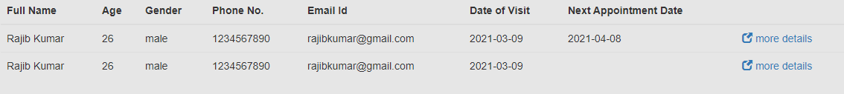

**Logout**

**Dr. Sen’s Dental Clinic**

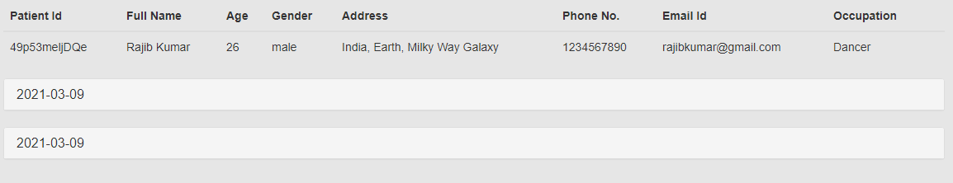

**Logout**

**Dr. Sen’s Dental Clinic**

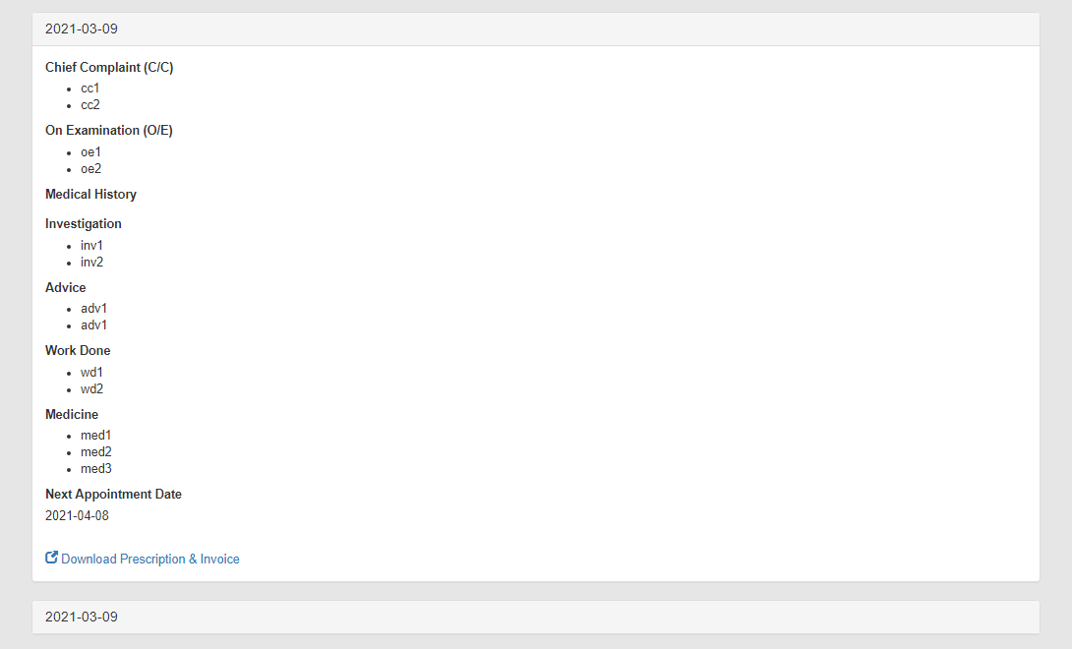

**Logout**

**Dr. Sen’s Dental Clinic**

**Logout**

**Dr. Sen’s Dental Clinic**